Best Day of My Life Strumming pattern: Hi “G”note-Down(3x)U-UDU”

American Authors

*Intro: Repeat Solo 1 twice* [NC] 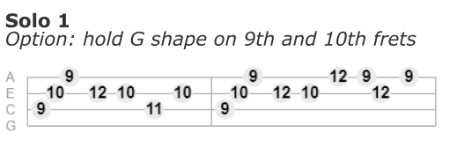

I [D]had a dream so big and loud I [D]jumped so high I touched the clouds

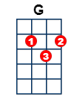

[G]Wo-o-o-o-o-o-oh, [G]Wo-o-o-o-o-o-oh

I [D]stretched my hands up to the sky

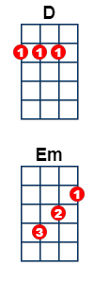

We [D]danced with monsters through the night

[G]Wo-o-o-o-o-o-oh, [G]Wo-o-o-o-o-o-oh

I'm [D]never gonna look back, no-o, [D]never gonna give it up, no-o

[Em]Please don't wake me [G]now[NC]

**Chorus:**[D]Oo-o-o-o-oo

[D]This is gonna be the best day of my [G]li-i-ife, my [G]li-i-i-i-i-i-ife

[D]Oo-o-o-o-oo

[D]This is gonna be the best day of my [G]li-i-ife, my [NC]li-i-i-i-i-i-ife

**Play Solo 2 twice** 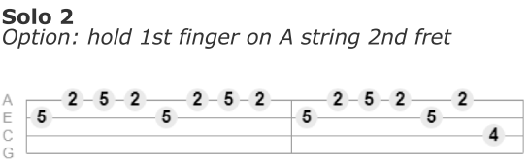

Background chords with solo: [D] [D] [G] [NC]

I [D]howled at the moon with friends, and [D]then the sun came crashing in

[G]Wo-o-o-o-o-o-oh, [G]Wo-o-o-o-o-o-oh

But [D]all the possibilities, no [D]limits just epiphanies

[G]Wo-o-o-o-o-o-oh, [G]Wo-o-o-o-o-o-oh

I'm [D]never gonna look back, no-o, [D]never gonna give it up, no-o

[Em]Please don't wake me [G]now[NC]

**Repeat chorus and Solo 2**

[D]I hear it calling, [D]outside my window [D]I feel it in my [D]soul (soul) [D]The stars were burning so bright, [D]the sun was out 'til midnight,

[D]I say we lose [D]control (ol)

**Repeat solo 1 twice** [NC]

**Final chorus**

*Based on Aldrine Guerrero Uke Lesson 79: https://ukuleleunderground.com/2014/06/uke- lesson-79-best-day-of-my-life-american-authors/*